HTTP VS HTTPS

Hyper Text Transfer Protocol Secure (HTTPS) is the secure version of HTTP. The 'S' at the end of HTTPS stands for 'Secure'. It means all communications between your browser and the website are encrypted. HTTPS is often used to protect highly confidential online transactions like online banking and online shopping order forms.

Web browsers such as Internet Explorer, Firefox and Chrome also display a padlock icon in the address bar to visually indicate that a HTTPS connection is in effect.

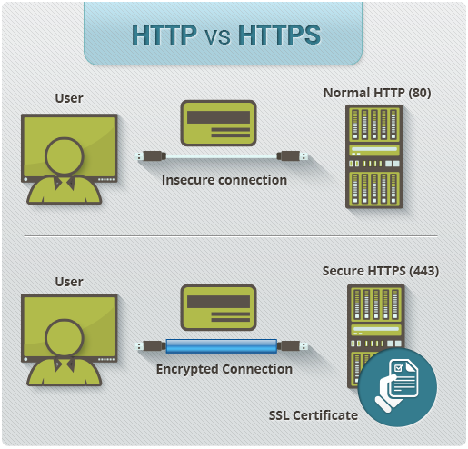

How Does HTTPS Work?

HTTPS pages typically use one of two secure protocols to encrypt communications - SSL (Secure Sockets Layer) or TLS (Transport Layer Security). Both the TLS and SSL protocols use what is known as an 'asymmetric' Public Key Infrastructure (PKI) system. An asymmetric system uses two 'keys' to encrypt communications, a 'public' key and a 'private' key. Anything encrypted with the public key can only be decrypted by the private key and vice-versa.

As the names suggest, the 'private' key should be kept strictly protected and should only be accessible the owner of the private key. In the case of a website, the private key remains securely ensconced on the web server. Conversely, the public key is intended to be distributed to anybody and everybody that needs to be able to decrypt information that was encrypted with the private key.

What is a HTTPS certificate?

When you request a HTTPS connection to a webpage, the website will initially send its SSL certificate to your browser. This certificate contains the public key needed to begin the secure session. Based on this initial exchange, your browser and the website then initiate the 'SSL handshake'. The SSL handshake involves the generation of shared secrets to establish a uniquely secure connection between yourself and the website.

When a trusted SSL Digital Certificate is used during a HTTPS connection, users will see a padlock icon in the browser address bar. When an Extended Validation Certificate is installed on a web site, the address bar will turn green.

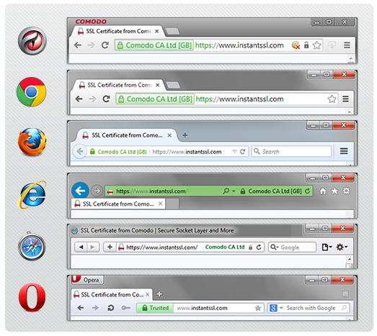

Here are some major differences between HTTP and HTTPS:

|  |  |
| --- | --- |
| **HTTP** | **HTTPS** |
| URL begins with “http://” | URL begins with “https://” |
| It uses port 80 for communication | It uses port 443 for communication |
| Unsecured | Secured |
| Operates at Application Layer | Operates at Transport Layer |
| No encryption | Encryption is present |
| No certificates required | Certificates required |

READ :-

Hyper Text Transfer Protocol Secure (HTTPS) is the secure version of HTTP. The 'S' at the end of HTTPS stands for 'Secure'. It means all communications between your browser and the website are encrypted. HTTPS is often used to protect highly confidential online transactions like online banking and online shopping order forms.  
  
HTTPS pages typically use one of two secure protocols to encrypt communications - SSL (Secure Sockets Layer) or TLS (Transport Layer Security). Both the TLS and SSL protocols use what is known as an 'asymmetric' Public Key Infrastructure (PKI) system. An asymmetric system uses two 'keys' to encrypt communications, a 'public' key and a 'private' key. Anything encrypted with the public key can only be decrypted by the private key and vice-versa.

As the names suggest, the 'private' key should be kept strictly protected and should only be accessible the owner of the private key

Cookies :

PHP transparently supports HTTP cookies. Cookies are a mechanism for storing data in the remote browser and thus tracking or identifying return users. You can set cookies using the setcookie() or setrawcookie() function. Cookies are part of the HTTP header, so setcookie() must be called before any output is sent to the browser. This is the same limitation that header() has. You can use the output buffering functions to delay the script output until you have decided whether or not to set any cookies or send any headers.

<?php

$cookie_name = "user";  
$cookie_value = "John Doe";  
setcookie($cookie_name, $cookie_value, time() + (86400 * 30), "/"); // 86400 = 1 day  
?>

<html>

<body>  
<?php  
if(!isset($_COOKIE[$cookie_name])) {

echo "Cookie named '" . $cookie_name . "' is not set!";

} else {

echo "Cookie '" . $cookie_name . "' is set!<br>";

echo "Value is: " . $_COOKIE[$cookie_name];

}

?>